Iterative and Incremental

model

# **Iterative model**

# To avoid the bottlenecks of the waterfall model, the iterative model was introduced in 1980. In the model under consideration, the process is very straightforward: specific steps in a specific order, moving from point A to point B, and the result is the final product.

In the iterative model, the first version of the product is made, it is reviewed, it is decided whether the right path has been chosen. A new iteration begins: the product is improved, it is reviewed, it is decided whether the right path has been chosen. A new iteration begins until the product is ready:

In the iterative model, the entire process is divided into several stages (here and further – iteration), each iteration lasts 2-6 weeks. At the beginning, the more critical part of the software is prepared, essentially following the same steps as in the waterfall model. During the next iteration, the software is improved, creating new functionality or improving what was done previously. Iterations are multiplied until the project is completed. When the software is ready, it is put into use. The results of the risk analysis are taken into account to better guide the process. The iterative model can be shown as follows:

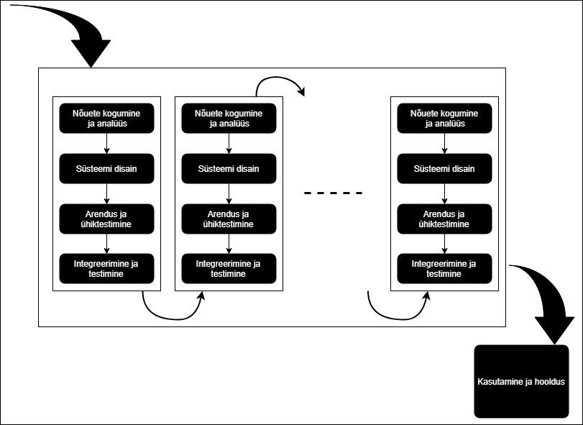

## **Advantages of the iterative model**

Since you can start quite quickly, the first results will also come quickly, which helps the business (customer) better understand whether the project is going in the right direction. This also makes risk management easier. The project is easily measurable, which is why it is suitable for large clients for whom precise management of a large budget is important. Theoretically, it is possible to launch several iterations in parallel, which speeds up the process of reaching the finished product. Learning from mistakes – you can avoid risks and errors discovered during the previous iteration. The iterative model is flexible – it is possible to change the initial requirements during the project.

## **Disadvantages of the iterative model**

Due to its flexibility, this model requires very strong and continuous project management. Managing the work resource is more difficult and requires more manpower than the waterfall model (in the waterfall model, the analyst has a stable and continuous job at the beginning of the project, later only a supporting function, then he can be directed to another project, etc.). Problems can arise in architectural design if the team working on the project is not very foresightful or experienced. Risk analysis requires additional manpower and is expensive.

## **When to use an iterative model?**

1. There is a general picture of what you want to achieve. Smaller tasks can be specified later.
2. The project is large. If there is a risk that the project will take a long time, it is worth adopting an iterative model, as it allows for parallel iterations: it minimizes the risk that the software needs/requirements will change by the end of the project.

# Iterative model: <https://web.htk.tlu.ee/digitaru/tarkvara/chapter/tarkvaraarenduse-etapid/>

**Incremental model**

Incremental Model is a process of software development where requirements divided into multiple standalone modules of the software development cycle. In this model, each module goes through the requirements, design, implementation and testing phases.

Every subsequent release of the module adds function to the previous release. The process continues until the complete system achieved.

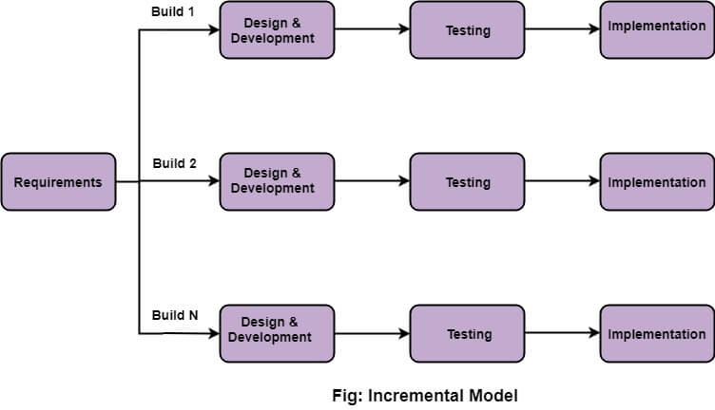

## The various phases of incremental model are as follows:

1. Requirement analysis: In the first phase of the incremental model, the product analysis expertise identifies the requirements. And the system functional requirements are understood by the requirement analysis team. To develop the software under the incremental model, this phase performs a crucial role.

2. Design & Development: In this phase of the Incremental model of SDLC, the design of the system functionality and the development method are finished with success. When software develops new practicality, the incremental model uses style and development phase.

3. Testing: In the incremental model, the testing phase checks the performance of each existing function as well as additional functionality. In the testing phase, the various methods are used to test the behavior of each task.

4. Implementation: Implementation phase enables the coding phase of the development system. It involves the final coding that design in the designing and development phase and tests the functionality in the testing phase. After completion of this phase, the number of the product working is enhanced and upgraded up to the final system product

## When we use the Incremental Model?

* When the requirements are superior.
* A project has a lengthy development schedule.
* When Software team are not very well skilled or trained.
* When the customer demands a quick release of the product.
* You can develop prioritized requirements first.

## Advantage of Incremental Model

* Errors are easy to be recognized.
* Easier to test and debug
* More flexible.
* Simple to manage risk because it handled during its iteration.
* The Client gets important functionality early.

## Disadvantage of Incremental Model

* Need for good planning
* Total Cost is high.
* Well defined module interfaces are needed.

Incremental model:<https://www.tpointtech.com/software-engineering-incremental-model>